ANNUAL EXAM -2023
Class: IX [Social Science] Date: 20/02/2023 Time: 3 hrs. MM: 80
General Instructions:
- Question paper comprises 6 sections ABCDE&F. There are 37 questions in the question paper. All questions are compulsory.
- Section A from Q1 to Q20 are MCQs of 1mrks.
- Section B from Q21 to Q24 are Very Short Questions carrying 2 marks each.
- Section C from Q25 to 29 Short Questions carrying 3 marks each.
- Section D from Q30 to 33 Long Questions carrying 5 marks each.
- Section E from Q34 to 36 Case based questions carrying 4 marks each.
- Section F is Map based questions carrying 5 marks with two parts 37a from history (2 marks) and 37b from geography (3 marks).
- There is no overall choice in the question paper only internal choices has been provided in questions.
SECTION A. MCQ (1x20=20)
Q1 Jadidist were_within the Russian Empire -
- Muslim reformers c) Muslim educationist
- Parsi reformers d) German refugee.
Q2. Which of the following statements best explains pastoralist nomads?
- The villagers who move from one place to another.
- The people who do not have a permanent place to live in.
- The herdsmen who move from one place to another looking for pastures for their herd.
- The people who visit many places for enjoyment.
Q3.
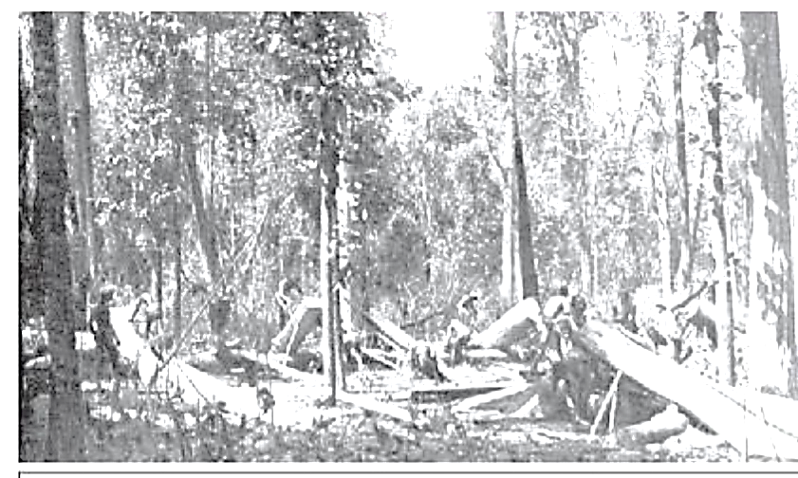
In the above picture the people of forest are doing which activity?
- Cutting trees for making ships. c) Cutting trees for making sleepers for tracs .
- Doing construction work. d) Clearing forest for cultivation.
Q4. Arrange the following events in chronological order:
  - Hitler was made chancellor of Germany.
  - Hitler committed suicide by gunshot in Berlin.
  - Hitler recoccupied Rhineland.
  - Hitler became the President of Germany.
Option: a) 1, 2,3,4. b) 1,3,4,2. c) 1,4,3,2. d) 4,2,3,1.
Q5. Identify the country which does not share land boundary with India
- Bhutan b) Bangladesh c) Tajikistan d) Nepal
Q6. Identify from the following physiographic division of India on the basis of features given below
- It is formed due to the breaking and drifting of Gondwana land.
- It has broad and shallow valleys.
- It has a rounded hills.
- It is composed of old crystalline igneous and metamorphic rocks.
Options:
i) Indian Desert ii) Peninsular Plateau iii) Northern Plains iv) Greater Himalayas.
Q7. Match the following:
List I. List II
1. The largest basin in India. (a). Rajasthan
2. Sambar Lake. (b).Dakshin Ganga
3.The other name of Godavari. (c) Ganga.
4. River flows through rift valley ( d ) Tapi .
Q8. Identify which of the following illustrates a support to democracy:
- Democracy has ever gone to war with others.
- A ban on political gathering by a monarch.
- Right to vote from citizens of foreign origin .
- Open criticism of ruling party leader in the media.
Q9. Which of the following term is not included in the preamble to the Indian Constitution:
- Liberty b) Equality c) Secular d) Religion
Q10. What makes an election democratic? Select the correct option
- Universal Adult Franchise c) Fundamental Rights
- Directive Principles of State Policy d) Free and Fair elections
Options: i) b (ii) c (iii) b&c. (iv) a&d.
Q11.Match the following:
List I. List II
1. Head of the State. A. Supreme Court
2. Final authority in law making of India. B. Prime Minister
3. Head of Govt . C. Parliament
4. Settles disputes between citizens and govt. D. President
Option:
- 1-A; 2-B; 3-C; 4-D. b) 1-D; 2-C; 3-B; 4-A. c)1-D; 2-A; 3-C; 4-B. d) 1-B; 2-D; 3-A; 4-C.
Q12. There are two statements marked as assertion (A) and reason ( R ) mark your answer as per the codes provided below:
Assertion: every person has a right to profess practice and propagate the religion he or she believes in.
Reason: any section of citizens with a distinct language or culture have a right to conserve it.
- Both A and R are true and R is the correct explanation of A.
- Both a and R are true but R is not the correct explanation of A.
- A is true but R is false.
- A is false but R is true.
Q13. What is apartheid?
- A system of Racial Discrimination. c) Discrimination of Caste.
- Discrimination on Education. d) Discrimination on Economy.
Q14.
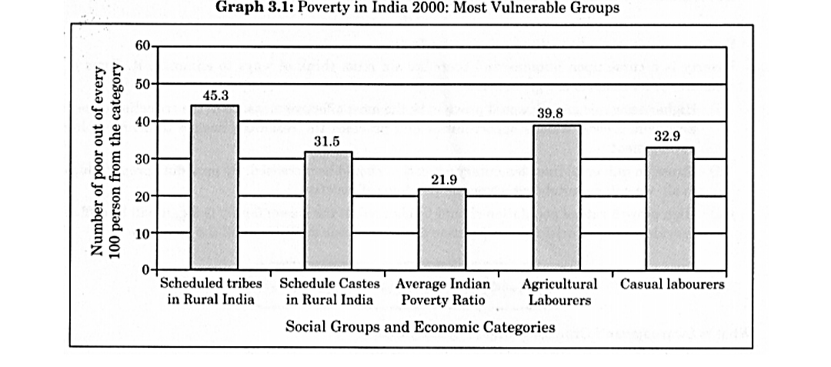
Read the given graph and find out which group is the most vulnerable group:
- Casual labour. c) Schedule Castes in rural areas.
- Schedule Tribe in rural areas. d) Agricultural labourers.
Q15.
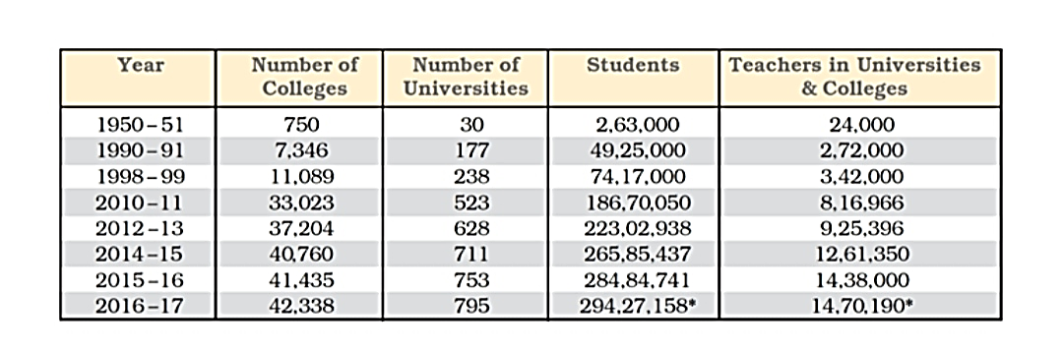
Observe the table given and answer the following:
The increase noticed in the number of colleges in the year 2016-17 as compared to 2012-13 was:
- 5134 b) 750 c) 711 d) 4532.
Q16. Find odd one out from the following:
- Land, labour ,capital and human capital.
- Mining, agriculture , fishing.
- Small scale industries ,large scale industries , cottage industries.
- Teaching ,banking, finance.
Q17. Fill in the blanks-
Land (in hectare) Palampur. No of families
Less than 2. 240
More than 2. ___?__
Option: a) 450 b) 150 c) 60 d) 80
Q18.Analyse the given info and consider one as correct option.
- Food security is not successful in Tamil Nadu.
- Buffer stock is always looked after by the private companies.
- Ration shops are also known as issue prices.
- India has become self sufficient in food grains due to Green Revolution.
Q19. In which state more than 90% ration shops are run by cooperative.
- Andhra Pradesh b) Tamil Nadu c) Odisha d) Bihar
Q20. Identify the correct statement from the following:
- The accepted average calories requirement in urban area in India is 2100 calories.
- Accepted average calories requirement in rural areas in India is 2200 calorie.
- The poorest state in India is Gujrat.
- Women, children and old people are the richest of rich .
Section B. Very Short Questions - (2x4=8)
Q21. What was the theme of the Book "The Spirit of the Laws" and who wrote it?
Q22. Mention any two reasons why preamble is important.
Q23. Why is Peninsular Plateau of India known as the store house of minerals? Give two reasons.
Q24.Mention two major losses that occurred due to modern farming.
Section C. Short Questions - (3x5=15)
Q25. Describe the consequences of Bastar Rebellion.
OR
What were the changes in the life of pastoralists?
Q26 . What are the three broad categories of division of population on the basis of their economic structure?
Q27. What are the dimensions of food security?
Q28. Mention any 3 main functions of Parliament.
Q 29.Write the major reasons for less effectiveness of the anti- poverty programme in India.
Section D - Long Questions - (5x4=20)
Q30. Mention the effects of economic crisis on Germany. OR Write salient features of Raikas or Massais.
Q31. Mention the features of winter season.
OR
Write the significant features of National Population Policy 2000.
Q32. Why is the Right to Freedom called a cluster of several rights.
OR
Explain any 5 powers of Supreme Court of India.
Q33. Mention the activities of FCI.
OR
Why is population very important for any country?
Section E- Source Based Questions -(4x3=12)
Q 34. In the deserts of Rajasthan lived the Raika's. The rainfall in the region was meager and uncertain. On cultivated land, harvest fluctuated every year. Over vast stretches no crop could be grown. So, the Raika's combined cultivation with pastoralism. During the monsoons the Raika's of Barmer, Jaisalmer, Jodhpur and Bikaner stayed in their home villages where pastures was available. By October, when these grazing grounds were dry and exhausted, they moved out in search of other pasture and water and return again during the next monsoon. One group of Raikas - known as the Maru(desert)Raikas- herded camels and another group reared sheep and goat.
- Name the pastoralist lived in Rajasthan. (1)
- What did the Maru Raikas herded? (1)
- What activities were carried out by the Raikas in October? (2)
Q35. On the basis of availability of water tropical deciduous forest are divided into moist and dry deciduous forests. The former is found in areas receiving rainfall between 200 and 200cm. These forest exist, therefore mostly in the eastern part of the country north- eastern states along the foothills of the Himalayas ,Jharkhand ,West Odisha and Chhattisgarh and on the eastern slope of Western ghats. Teak is the most dominant species in this forest. Bamboos, saal, shisham, sandalwood, khair, Kusum, Arjun, mulberry are other commercially important flora species.
- Mention any two commercially important species. (1)
- Which is the most dominant species of Tropical deciduous forest. (1)
- Write any two features of Tropical deciduous forest. (2)
Q36. The main purpose of election is to give people a chance to choose the representatives, the government and the policies they prefer. Therefore it is necessary to have a free and open discussion about who is better representative, which party will make a better government or what is good policy? This is what happens during election campaigns.
In our country, such campaigns take place for a two- week period between the announcement of the final list of candidates and the date of polling. During this period the candidates contact their voters, political leaders address election meetings and political parties mobilise their supporters. This is also the period when newspapers and television news are full of election related stories and debates. But election campaign is not limited to these two weeks only. Political parties starts repairing for election, months before they actually take place.
- What is the main purpose of election? (1)
- When does election campaign take place ? (1)
- What happens during the election campaigns? (2)

Section F - Map based questions (2+3=5)
Q37 (a). Two places A and B have been marked on the given outline map of France. Identify them and write their correct names on the lines drawn near them.
- Slave port .
- Capital of France.
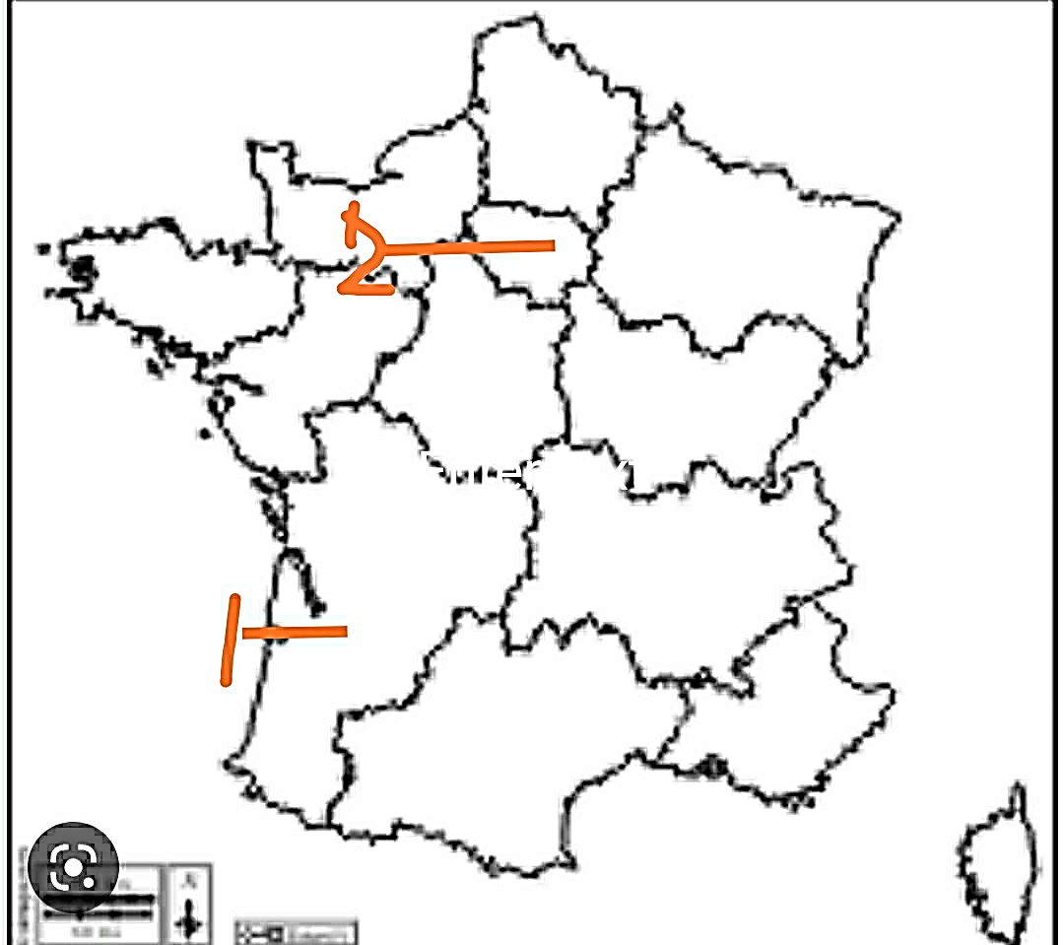

Q37 (b) locate and label the following on the outline of political map of India. (Any 3) .
- Standard Meridian of India
- River Narmada.
- National Park - Kaziranga.
- Montane Forest .
- A system having lowest density of population.

